|  |
| --- |
| FONTYS UNIVERSITY OF APPLIED SCIENCE |
| User Manual |
| Parcel Handling Simulation |
|  |
| **GDS - Group 3** |
| **1/13/2011** |

|  |  |  |
| --- | --- | --- |
| Document name |  | User Manual |
| Project name |  | Parcel Handling Simulation |
| Department |  | ICT |
| Client |  | Peter Boots |
| School tutor |  | Casper Schellekens |

|  |  |  |
| --- | --- | --- |
| Group leader |  | Qian Li |
| Group members |  | Antoine Girard |
|  |  | John Ibeagha |
|  |  | Kritian Kolev |
|  |  | Sebastien Lepage |

**Table of Contents**

1. Introduction 1

1.1 Project Background 1

1.2 Objective 1

1.3 Target Group 1

2. Application Overview 2

2.1 Image Overview 2

2.2 Function Description 3

3. Application Handling 6

3.1 Simulation Example 6

# Introduction

## Project Background

The parcel handling simulation project is to design a distributed application that is intended to resemble the parcel handling simulations at the airports. The application includes the simulations of the conveyors used to transport the parcels and baggage, the inputs, which are the check-in and parcel drop-off desks at the airport, the sorters that route the items to their destinations and the outputs, which are the destination gates of the parcels.

The application is fully implemented with all required functions. The users will be able to build the conveyors as they want by drawing lines on the working area. Each parcel will have a set of information including as a destination (plane/destination gate), ID, a priority based on urgency of delivery, etc. which would allow the sorters to navigate the parcel to its destination. The information of parcels and planes are generated by the users before running the simulation. Moreover, properties of storage capacity and belt speed can also be generated by the users.

## Objective

The current document will present an overview of the Parcel Handling Simulation application. It is intended to introduce the functions (buttons) and provide guidance to handle the application.

## Target Group

The current manual is set up for the end users who will be examining how the application will be working or who will be working partially in the simulation, such as managers from the airports, employees in the check-in desk, etc.

# Application Overview

## Image Overview

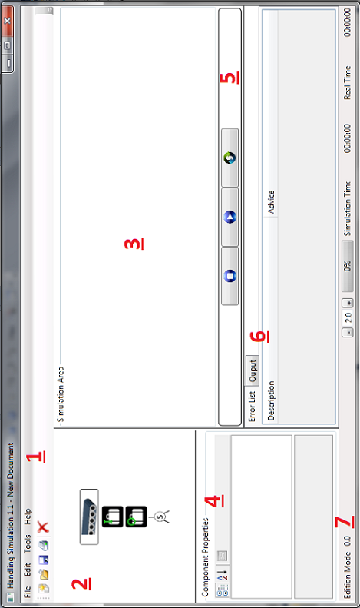

## Function Description

1. Toolbar

As most applications have, the toolbar includes File, Edit, Tools and Help functions for the end users to build their own simulation. The icons shown in the Toolbar are the shortcuts for mostly used functions when building a simulation.

|  |  |
| --- | --- |
|  | * New: open a new (blank) simulation area * Open: open an existing simulation * Save: save a new simulation or changes to a simulation * Save As: save a new/old simulation in a specific location * Print: print out the image of a simulation * Exit: close down the application |
|  | * Select All: select all the items in the simulation area * Unselect All: if there are items selected, they will be not selected any more * Delete: remove an item from the simulation area * Delete All: remove all the items in the simulation area |
|  | * Configuration: this will be explained below with images |
|  | * User Manual: clear and simple instructions for the end users to handle the project * About: description about the application |
|  | * From left to right: New, Open, Save, Print, Delete |

Configuration function:

|  |  |
| --- | --- |
|  | **Package Information Define**   1. The dropdown list will show the id of check-in gates. 2. Define the amount of parcels to the destination-gate chosen from the drop list. 3. A list of the information entered before. 4. Define the time between each parcel handled. 5. If every data is entered correctly, press “OK” button, otherwise “Cancel” button. |
|  | **Network Set up (Distributed system)**   1. Enter the IP Address, Port and Name for distributed system. 2. Status of network connection. |

1. Item Box

ItemBox contains the images of the items needed for drawing a simulation.

|  |  |
| --- | --- |
|  | From top to bottom:   * Conveyor * Check-in gate * Destination gate * Sorter |

1. Simulation Area

It is the place where the end users can design the simulation and draw it out.

1. Component Property Box

The component property box shows the properties for an chosen item.

1. Navigation Bar

The navigation bar is intended for users to handle a simulation.

|  |  |
| --- | --- |
|  | From left to right:   * Pause: to stop a running simulation * Start: to run a simulation * Check: to check the designed simulation to see whether it is correctly designed |

1. Output Control

The Output Control shows a list of errors in a designed simulation and advices for making it right. The list will be shown after the “Check” button is pressed in the Navigation Bar.

1. Status Bar

The Status Bar shows the status of a simulation, including Edition Mode.



* The speed of the simulation can be specified in the status bar.
* The percentage text shows the progress of a simulation.
* The time status is also shown here.

# Application Handling

To show exactly how the application works, an example will be demonstrated in this chapter, with every step from designing to compiling a simulation. The main functions will be explained in the example; however, not every function will be introduced. For the distributed system, 2 computers will be needed to act as server and client.

## Simulation Example

|  |  |
| --- | --- |
| **Server Side** | **Client Side** |
| 1. Open the application | 1. Open the application |
| 1. Drag items from the ItemBox to the simulation area (here, we draw a well-connected model) | 1. Drag items from the ItemBox to the simulation area (here, we leave some items unconnected by conveyors) |
| 1. Press “Check” button in the navigation bar and it shows no error | 1. Press “Check” button in the navigation bar, but it shows errors in the list, that some items are not connected.   Go to the model, connect the items. Check again till there’s no error |
| 1. Go to Toolbar, Tools -> Configuration -> Packages, and fill in the texts, press “OK” | 1. Go to Toolbar, Tools -> Configuration -> Packages, and fill in the texts, press “OK” |
| 1. In Windows command window, configure the IP address   Go to Toolbar, Tools -> Configuration -> Network, and fill in the IP. Press “Test” button. | 1. Go to Toolbar, Tools -> Configuration -> Network, and fill in the IP of the server, and press “Test” button. |
| 1. Close the configuration window. | 1. Close the configuration window. |
| 1. Press “start” button in the navigation bar. | 1. Press “start” button in the navigation bar. |
| 1. The simulation is running. | 1. The simulation is running. |